Sam Wood

13 September 2018

4: Pandas Homework

1. Two observable trends based on the school data:
   1. Increasing school size appears to have a significant negative effect on scores overall. In addition, increased spend per student has no effect on improved scores.

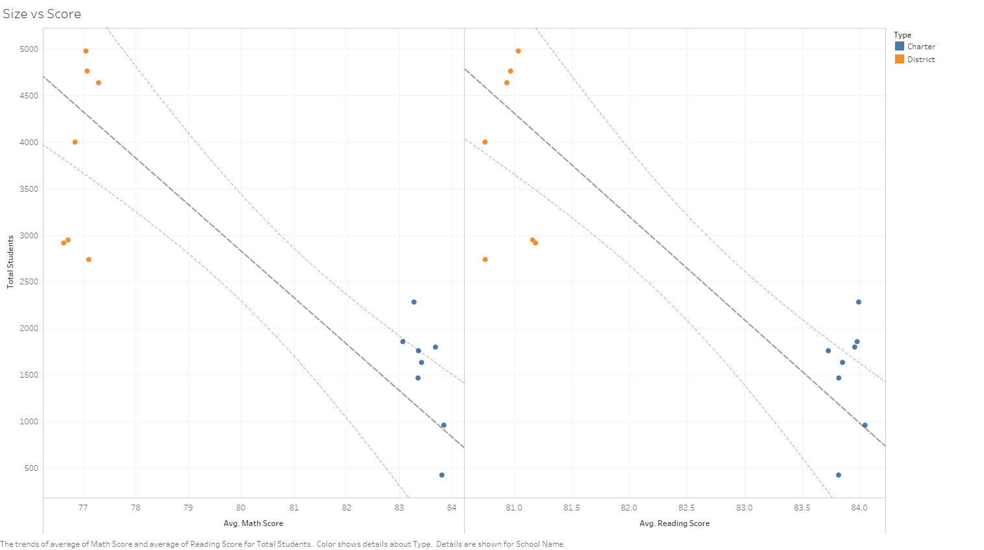

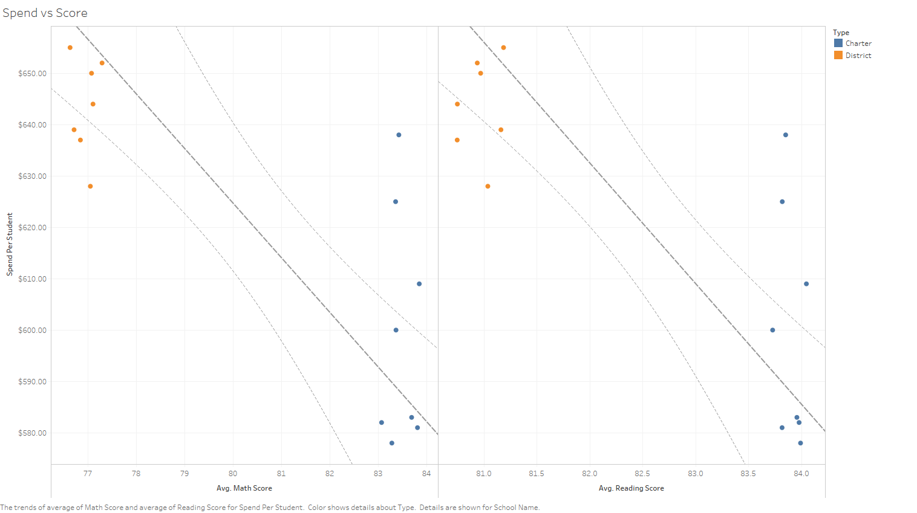

* 1. Charter schools outperform district schools across gender and grade.

